Microsoft Windows [Version 10.0.19045.2673]

(c) Microsoft Corporation. All rights reserved.

C:\Users\Nine\Desktop\DevOps Material\Vijay - 90 Days DevOps Challange>**git status**

On branch master

Untracked files:

(use "git add <file>..." to include in what will be committed)

Day 9/

nothing added to commit but untracked files present (use "git add" to track)

C:\Users\Nine\Desktop\DevOps Material\Vijay - 90 Days DevOps Challange>**git add .**

C:\Users\Nine\Desktop\DevOps Material\Vijay - 90 Days DevOps Challange>**git status**

On branch master

Changes to be committed:

(use "git restore --staged <file>..." to unstage)

new file: Day 9/Day 9 Tasks Soltion.docx

C:\Users\Nine\Desktop\DevOps Material\Vijay - 90 Days DevOps Challange>**git commit -m "Day 9 solution added"**

[master c06be95] Day 9 solution added

1 file changed, 0 insertions(+), 0 deletions(-)

create mode 100644 Day 9/Day 9 Tasks Soltion.docx

C:\Users\Nine\Desktop\DevOps Material\Vijay - 90 Days DevOps Challange>**git remote -v**

origin https://github.com/vtbarkade/Vijay_90_days_Devops_challange.git (fetch)

origin https://github.com/vtbarkade/Vijay_90_days_Devops_challange.git (push)

C:\Users\Nine\Desktop\DevOps Material\Vijay - 90 Days DevOps Challange>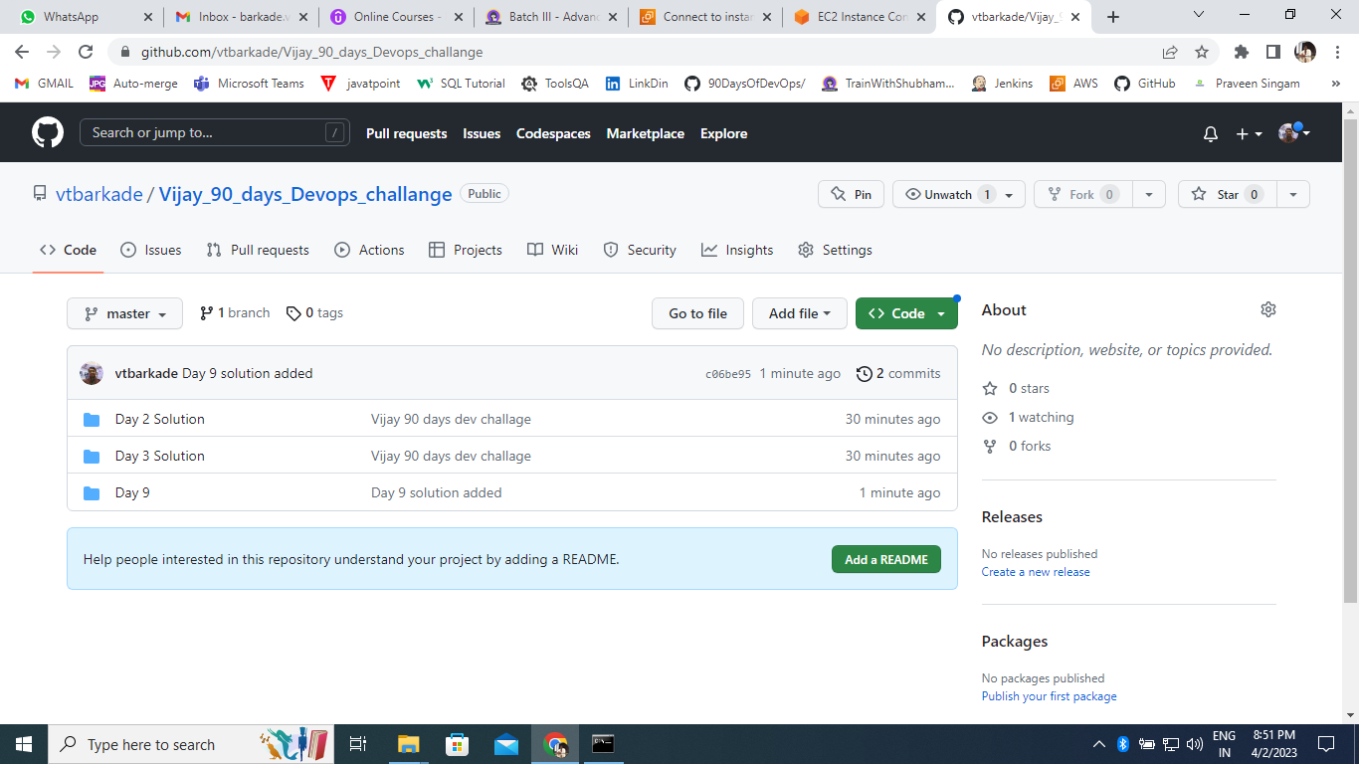

Enumerating objects: 5, done.

Counting objects: 100% (5/5), done.

Delta compression using up to 4 threads

Compressing objects: 100% (4/4), done.

Writing objects: 100% (4/4), 157.75 KiB | 10.52 MiB/s, done.

Total 4 (delta 1), reused 0 (delta 0), pack-reused 0

remote: Resolving deltas: 100% (1/1), completed with 1 local object.

To https://github.com/vtbarkade/Vijay_90_days_Devops_challange.git

4a67866..c06be95 master -> master